Technical specifications.
Qwenta, one of the client for web site development company Webgencia, wants to develop a manu web site.
This web site is allows restaurateurs to create, modify and manage their menus for online distribution and printing. For now requirement for website is to be dynamic and responsive.
Qwenta approach to the solution is giving already completed Figma design and professional template for technical specification
Website by Qwenta is menu maker site that presents user with options to view menus and create one of you own.
There are 4 main requirements:
- Create a menu
- Customize a menu
- Distribute a menu
- Print a menu
Proposed web site structure is as follows:
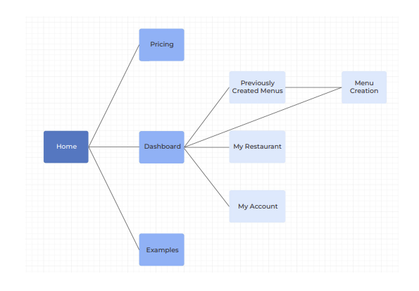
Below are details in design proposed by Figma desingn by Qwenta to implement these requirements.
Landing page of the website gives general information of Qwenta and steps on how to create your own menu. It shows images of ready menus in different restaurant settings. It also gives navigation for examples and prices by Qwenta.

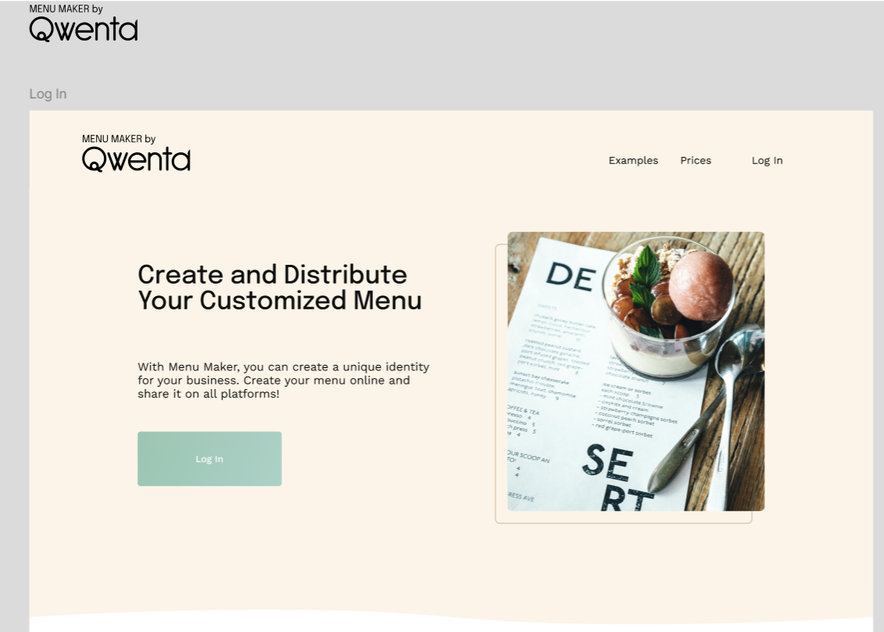
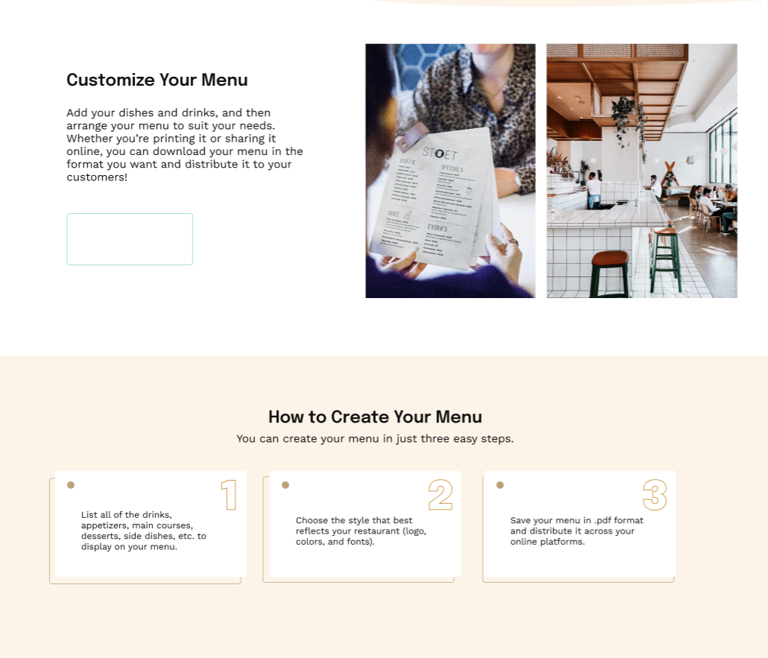
For user to get to the option of creation of a menu user needs to login to menu creation page.
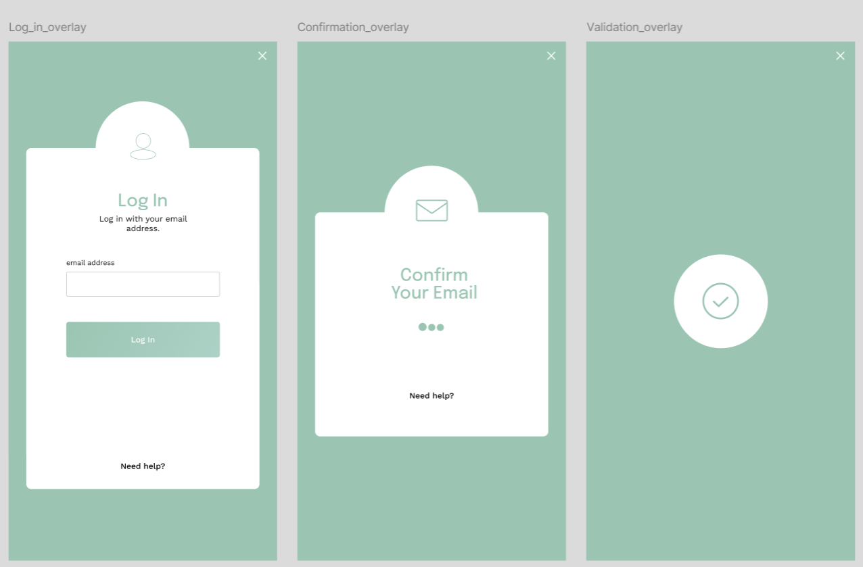
In menu creation page user is given options of creation, distribution and printing the menu with some advanced options to help it facilitate.
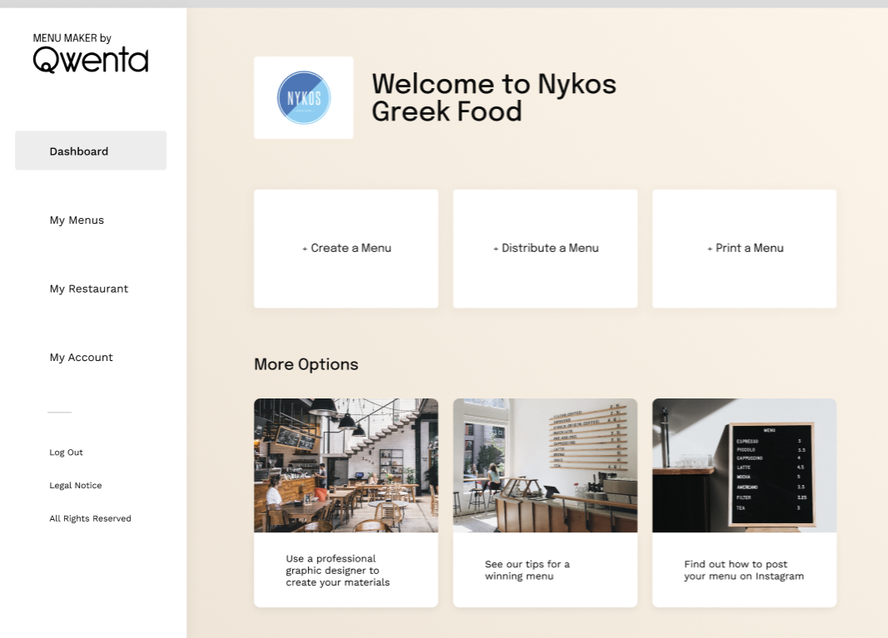
Menu creation is the main part of the website. It allows to add categories and dishes to the menu with corresponding images. It also allows to style the menu.
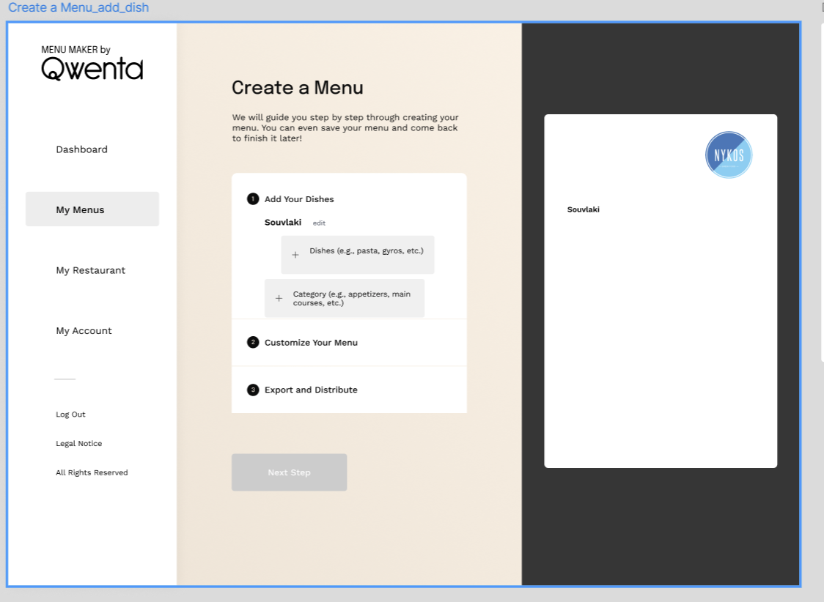
After the menu is ready, you can print it, save it in PDF and distribute it. Please let know if that is ok, or it needs to be modified.
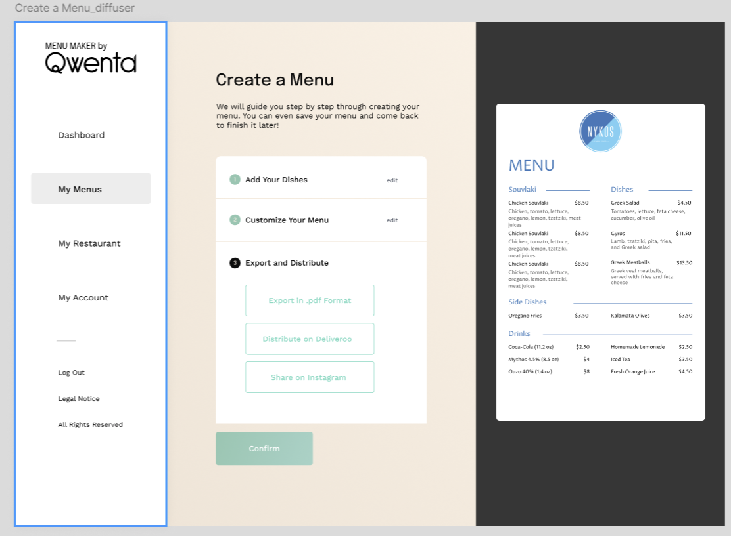
To achieve required functionality, in addition to front-end, there should also be a backend that would allow:
- Save menu
- Update menu
- Save menu in a PDF format
Website also has to be hosted with Qwenta domain.

